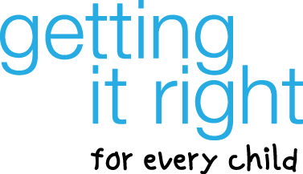

GIRFEC PRACTICE DEVELOPMENT SESSIONS

Promoting Awareness of GIRFEC to Families – A Toolkit for Practitioners
and
Joint Inspection of Services for Children & Young People

GIRFEC Practice Development Sessions are being held across 7 areas throughout June.

- Thursday 4th June 3.30-5.15pm in Woodmill High School
(Dunfermline Area)
- Tuesday 9th June 3.30-5.15pm in Parkgate Community Centre
(South West Fife Area)
- Wednesday 10th June 3.30-5.15pm in Kennoway Primary School
(Levenmouth Area)
- Thursday 11th June 3.30-5.15pm in the Lomond Centre
(Glenrothes Area)
- Thursday 11th June 3.30-5.15pm in Benarty Centre
(Cowdenbeath Area)
- Tuesday 16th June 4.00-5.45pm in County Buildings, Cupar
(North East Fife Area)
- Wednesday 17th June 3.30-5.15pm in Kirkcaldy High School
(Kirkcaldy Area)

The sessions will provide an opportunity for practitioners to consider ways to support and promote parents/carers awareness and understanding of GIRFEC and further discussion about the GIRFEC Pathway.

To register for one of the sessions please complete the details below and return to Joanne.Erskine@fife.gov.uk by Wednesday 27th May stating which session you wish to attend.

Can you please register for the event in your area where possible. Places are limited therefore early booking is recommended.

We look forward to seeing you at one of the forthcoming sessions.

GIRFEC Practice Development Sessions
Name: …………………………………………………………………………………………
Email address ………………………………………………………………………………..
Service/Agency ………………………………………………………………………………
Preferred Session/Date ……………………………………………………………………..

