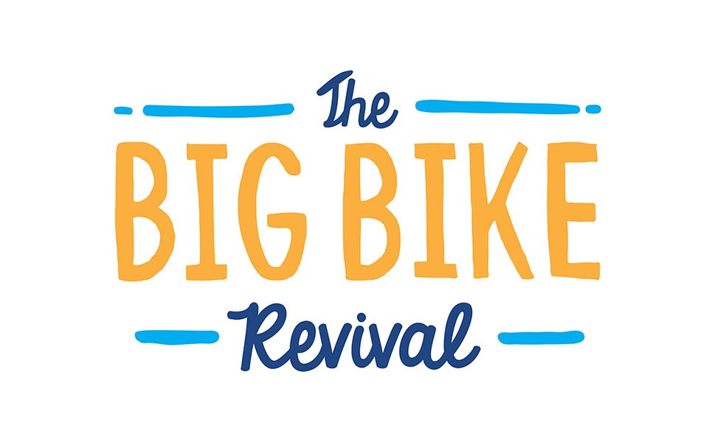

Grant Application Form

Organisation Name:
Grant amount: | £

Target Number of participants to events:

Main Contact:

Full Postal Address: Line 1

Line 2

Line 3

Local Authority

Telephone:

Email:

Type of Organisation:
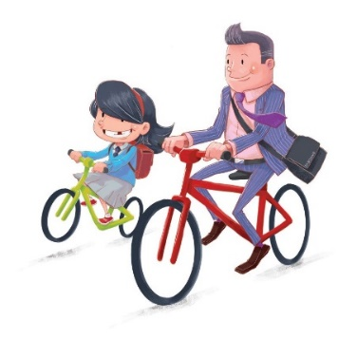

The Big Bike Revival
The Big Bike Revival (BBR) in Scotland is a campaign to help achieve the Scottish Government vision of 10% of journeys by bike by 2020. It aims to get more people cycling, which is the mission that sits at the core of Cycling UK, its members and the network of sustainable cycling groups that it supports.
The Big Bike Revival in Scotland will use a proven and award winning social marketing campaign to engage the public and to present opportunities to fix a bike, learn how to keep it serviceable and gain the confidence to make cycle journeys that replace trips typically made by motorised vehicles. People will be encouraged to participate in fun, social and inclusive events that present cycling as a practical, normalised and everyday activity.
The BBR events programme will provide opportunities for people across Scotland to dust off the bike, brush up on cycling skills and to start cycling again. Participants will be encouraged to celebrate their re-kindled love for cycling by participating in an inclusive and inspiring programme of social cycle rides. Participants engaged in the Big Bike Revival will also be provided with the opportunity to set up or join a local cycling groups to help them keep cycling.

How to participate

If you think you can play a role in this nationally significant intervention and help us deliver ambitious outcomes, we would like to hear from you. In return for your commitment to be involved we are offering funding support of up to £1,000 (inclusive of any VAT charges) for you to engage with your community and get more people on bikes. Funding can be used to cover incremental costs associated with dedicated Big Bike Revival initiatives, for example:
- To purchase additional bike maintenance tools, spares or equipment
- To cover additional staff costs, volunteer costs or contracted resources
- To pay for cycle maintenance training courses to build delivery capacity
- To procure services from event specialists, e.g. cycle display teams
- To hire specialist equipment for the delivery of public engagement events
- To rent a room or venue for the delivery of Big Bike Revival initiatives
- To run cycle instructor led initiatives such as workshops and led rides

The programme will provide each participating organisation with a fully supported social marketing campaign that will give access to a number of key resources such as:
- A listing on a national directory of bike recycling organisations; a dedicated website that the public will access to find out where to participate
- A centrally coordinated digital marketing campaign & local and national media exposure
- The Big Bike Revival branded marketing materials including bunting and printed publicity materials
- A comprehensive evaluation framework

Please complete and return this form at least 2 weeks prior to your first event to ensure we can process your application and provide you with the required support:
By email:
Shona.morris@cyclinguk.org
Once we have reviewed your application, successful participants will receive a BBR grant claim form and next step instructions.

Tell us about your organisation

What, if any, cycling related activities are currently supported by your organisation? e.g. led rides, Dr Bike etc. (max 100 words)

Who would you describe as your target audience and how do they currently access your services? e.g. referral schemes, open to public, open workshop, opening hours etc. (Max 100 words)

Number of people currently supported through your services (on average)?

Weekly: Monthly: Annually:

Tell us about your Big Bike Revival plans
Brief description of how you plan to participate (max 200 words):

Proposed Big Bike Revival Activity Schedule (1st May – 11th June 2017)
Please indicate proposed BBR event activities below (add fields if needed)

Event Title | Centre Name | Event Date (DD/MM/YYYY) | Start Time | End Time | Event Address | Event Postcode | Additional Directions | Short Description  (max 50 words) | Please indicate the type of event with a 'X'…
 |  |  |  |  |  |  |  |  | Entertainment | Refreshments | Bike Donations | Bike maintenance tips | Puncture repair workshops | Bike health checks | Bike safety tips | Led bike rides

Tell us about your plans to host a BBR Led Ride
Participating organisations are encouraged to facilitate BBR led ride events in October 2017. Will you be facilitating a led ride during this period?

If YES, please provide detail of your proposed led ride activity.
Date(s): | Type of Ride(s): | Estimated number of riders that can participate:

Marketing
Proposed Marketing (what local channels will you use to promote BBR and / or how could marketing be expanded?) (Max 100 words)

Target Audience (who do you hope to reach through this event schedule that you may not reach currently?) (max 100 Words)

Press Quote (Provide a supportive statement on why you are involved with BBR, that we can insert in any local press releases or in response to media queries.)(max 100 words)
Facebook ID:
Twitter Account:
Website Address:
Other social media address:

Budget

Item | Cost (£)
TOTAL COST (inclusive of any VAT charges) | £

Match Funding

Line Item | Value (£)
Budget from other grant sources used for BBR Events
Unrestricted funds / resources used for BBR Events
Volunteer Hours
Other
TOTAL Match Funding | £

